|  |
| --- |
| AIM Duration: 2hour |
| * Draw sketches using paint |

|  |
| --- |
| REQUIREMENT |

|  |
| --- |
| List of Hardware/Software requirements:   * Computer Desktop/Laptop * Windows Operating system * Open Office |

PROCESDURE

* Task 1: **Draw a Smiley.**
* Step 1: Open the Open Office and go to Drawing.



* Step 2: take a blank Drawing sheet.
* Step 3: Then you can see the right side of the open office. Go to the properties and select shapes.

. 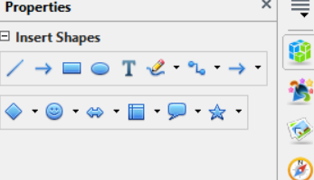

* Step 4: Take a Smiley and Draw on the sheet with the help of Mouse. Just click-and drag to create the drawing object. Release the mouse button. Then you can see your drawing and fill the color’s.

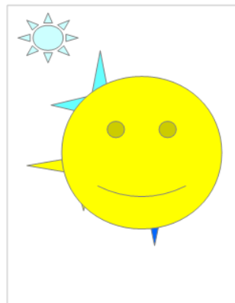

* Task 2: **Draw a Star.**

Step 1: Insert a blank page.

Step 2: Go to the properties and select Stare shape.

 

Step 3: Take a Star and Draw on the sheet with the help of Mouse. Just click-and drag to create the drawing object. Release the mouse button. Then you can see your drawing and fill the color’s.

